Market Management System

Username

Password

Confirm password

Sign up

clear

**SIGN UP**

Username

Password

Sign in

clear

**LOG IN**

admin

seller

Username

Password

Sign in

clear

**LOG IN**

admin

seller

Dashboard

username

Shitjet/Trans

Te dhenat e artikujve

Lokacionet

Stoku

Prodhimi

Recepturat

Furnitoret

Userat & Rolet

|  |  |  |  |  |
| --- | --- | --- | --- | --- |
|  |  |  |  |  |
|  |  |  |  |  |
|  |  |  |  |  |
|  |  |  |  |  |
|  |  |  |  |  |

Dashboard

username

Shitjet/Trans

Te dhenat e artikujve

Lokacionet

Stoku

Prodhimi

Recepturat

Furnitoret

Userat & Rolet

PRODUCTS

ORDES

SALES

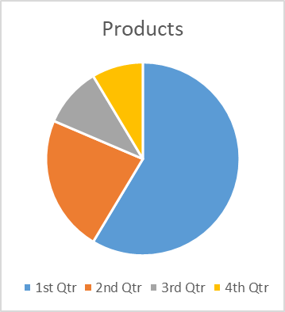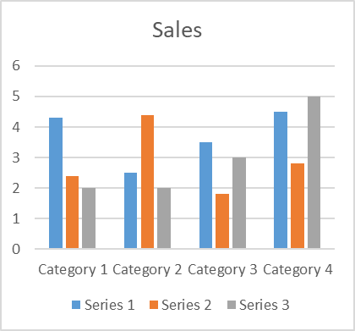

**Produktet**

Dashboard

username

Shitjet/Trans

Produktet

Lokacionet

Stoku

Prodhimi

Recepturat

Furnitoret

Userat & Rolet

**ID | Name | Price | Quantity | Category**

Dashboard

username

Shitjet/Trans

Te dhenat e artikujve

Lokacionet

Stoku

Prodhimi

Recepturat

Furnitoret

Userat & Rolet

**Bills**

Dashboard

username

Shitjet/Trans

Te dhenat e artikujve

Lokacionet

Stoku

Prodhimi

Recepturat

Furnitoret

Userat & Rolet

Dashboard

username

Shitjet/Trans

Te dhenat e artikujve

Lokacionet

Stoku

Prodhimi

Recepturat

Furnitoret

Userat & Rolet

**ID | Name | Price | Quantity | Category**

//Comment: same list shit here

To:

D/m/y

From:

D/m/y

Search

Print as Excel File…

Dashboard

username

Shitjet/Trans

Te dhenat e artikujve

Lokacionet

Stoku

Prodhimi

Recepturat

Furnitoret

Userat & Rolet

**ID | Name | Price | Quantity | Category**

…..

Search

To:

D/m/y

From:

D/m/y

//Comment: idk which way to choose where u put date, month, year, time however you’d like or where u put from which date to which date and idk the f else to add

Print as Excel File…

Dashboard

username

Shitjet/Trans

Te dhenat e artikujve

Lokacionet

Stoku

Prodhimi

Recepturat

Furnitoret

Userat & Rolet